Note: This document is “view only”. Please create a copy of this document and save it to your drive.

**SOP- Lastpass Backup- Systems Vault**

**PREREQUISITES**

[Master: SOP- Operations Management -Systems Vault](https://docs.google.com/document/u/0/d/1gIeHLaKTWivg43RAx2fHPd14QktmUju8dcElYWywAXM/edit)

Lastpass Admin Access

SN Lastpass Backups

**PURPOSE**

To ensure all passwords are backed up and accessible.

**POLICY**There are monthly recurring tasks in [Teamwork PM](http://sarahnoked.com/teamwork) to backup passwords

All backups are saved in the SN Lastpass Backups folder.

Backups are exported as encrypted files.

**PARTY**

Tech VA

**PROPERTY**

Online Business Manager

**PROCESS**

Part 1: Generate a Backup

Part 2: Save the Backup to Google Drive

**PROCEDURE**

**Part 1: Generate a Backup**

1. Click on the lastpass icon in your browser
2. Make sure you are signed into the passwords@sarahnoked.com lastpass account
3. Generate and save the backup
   1. Go to passwords@sarahnoked.com Account Options > Advanced > Export > Export to > Lastpass Encrypted File

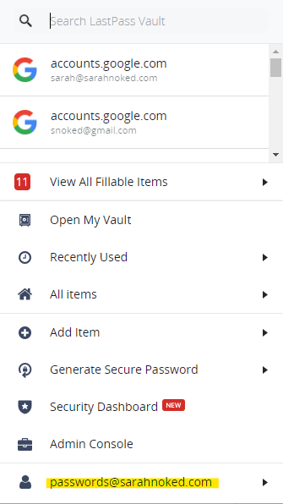

* 1. This creates a comma-separated unencrypted list of all your LastPass entries to a plain text file which you will be prompted to download.

1. Enter the master password then click continue

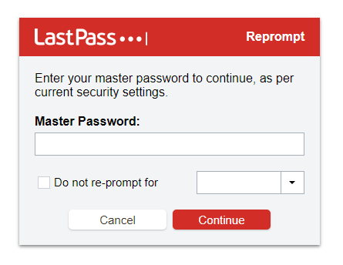

1. Create a strong encryption key and make sure to list it down somewhere safe.

Use this naming convention: **SarahNokedOBM042021!** (SarahNokedOBM + month + year + !)

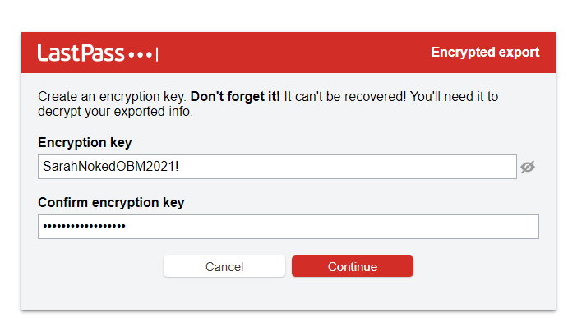

1. Save that file to your desktop with the name: lastpass backup + date

**Important** If this does not work and you are not prompted to download a file but only get a new window with the details, try doing this same process but in firefox.

**Important** If you go to Export and do not see the 'LastPass Encrypted File' option, this is because you do not currently have the binary component installed.

To Install the binary component:

Click on the LastPass Icon on > More options > About lastpass > Enable Native Messaging. If necessary, restart the browser and try again to export encrypted file  
  
**For CHROME, follow this link:**<https://lastpass.com/support.php?cmd=showfaq&id=5576>

**Part 2: Save the Backup to Google Drive**

1. Access the google drive folder named ‘Teamwork’ > SarahNoked.com > Sarah Noked Backups> [Lastpass Backups](https://drive.google.com/folderview?id=0B0ImtcKvH65USnJkek9oSmpVQ2s&usp=sharing).
2. Save the Backup.

**Created by:**

**Department:** Operations & Support

**Date:**

**Revised:**

**Revised By:**